8-bit Pixel Art Challenge

In this tutorial, you are going to create a piece of 8-bit pixel art using touchdevelop.
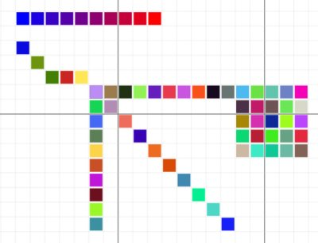

getting started

First you need to visit:

https://www.touchdevelop.com/wkbj

If you have a Microsoft account, you will be able to login. You can create an account for yourself or use the app without logging in.

using the tutorial

Click the tutorial button

Follow the instructions step by step. Make sure you read the information that appears between each step so that you gain an understanding of what the code is doing (You will need to write your own instructions later).
remembering instructions

Write the result of each instruction below so that you can use them later when customizing your app:

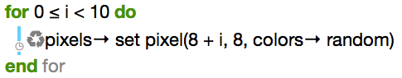

the challenge

Using what you have learnt, create your own 8-ball pixel artwork. Suggestions:

