turtle power (Beginner)

In this tutorial, you will learn how to create simple algorithms to instruct a turtle to draw amazing artwork.

getting started

First you need visit:

https://www.touchdevelop.com/eantb

If you have a Microsoft account, you will be able to login. You can create an account for yourself or use the app without logging in.

using the tutorial

Click the tutorial button

Follow the instructions step by step. Make sure you read the information that appears between each step so that you gain an understanding of what the code is doing (You will need to write your own instructions later).

remembering instructions

Write the result of each instruction below so that you can use them later when customizing your app:

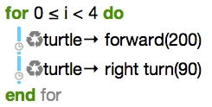

the challenge

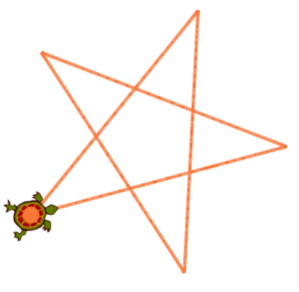
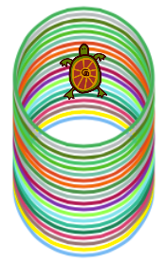
Now you’ve mastered the basics, why not have a go at designing your own shapes! Here are some ideas to get you started:
