Magic 8-Ball

In this gentle introduction to TouchDevelop, you are going to create a "Magic 8-Ball" game that will convince your friends that it can predict the future.
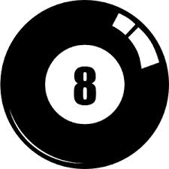

getting started

First you need to visit:

https://www.touchdevelop.com/ozryb

If you have a Microsoft account, you will be able to login. You can create an account for yourself or use the app without logging in.

using the tutorial

Click the tutorial button

Follow the instructions step by step. Make sure you read the information that appears between each step so that you gain an understanding of what the code is doing (You will need to write your own instructions later).
remembering instructions

Write the result of each instruction below so that you can use them later when customizing your app:

the challenge

Using what you have learnt, create your own “Magic 8-Ball game” with your own set of responses. Suggested improvements:

- Add more responses. The Magic 8 Ball is made up of 20 responses – 10 positive, 5 negative and 5 neutral. The full list of answers are: Positive answers: It is certain; It is decidedly so; Without a doubt; Yes definitely; You may rely on it; As I see it, yes; Most likely; Outlook good; Yes; Signs point to yes. Negative answers: Don't count on it; My reply is no; My sources say no; Outlook not so good; Very doubtful. Neutral answers: Reply hazy try again; Ask again later; Better not tell you now; Cannot predict now; Concentrate and ask again.
- Add comments to your script to explain how it works
- Modify your script so that the 8-ball speaks the prediction out aloud using the Languages speak text command.

